Chapter 5, Problem 66

For the circuit in Fig. 5.93, find v_{o}.

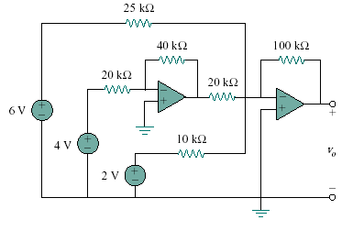
Figure 5.93
For Prob. 5.66.

